**Project Deadline 2**

**Relational Model:-**

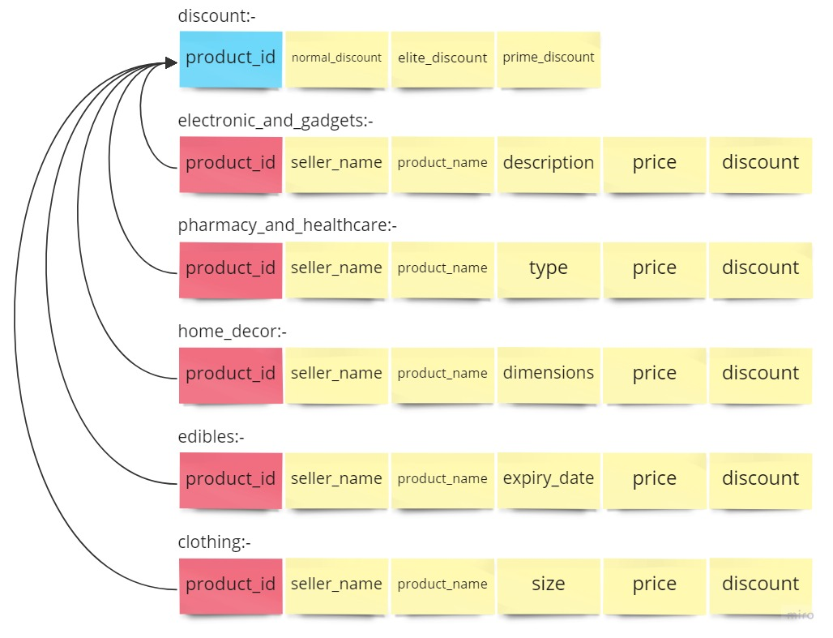

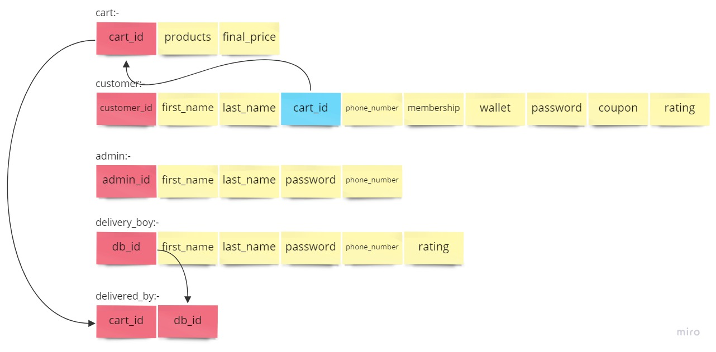

**ER Model:-**

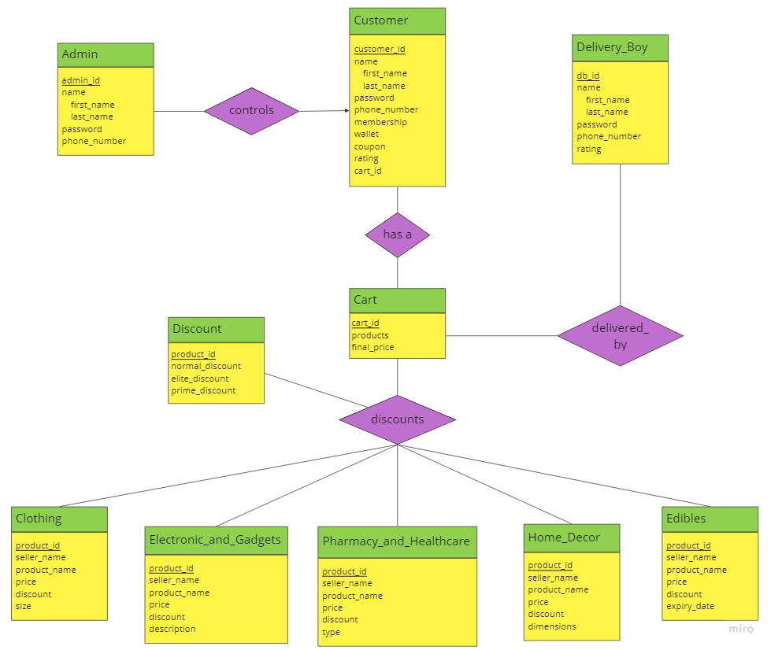

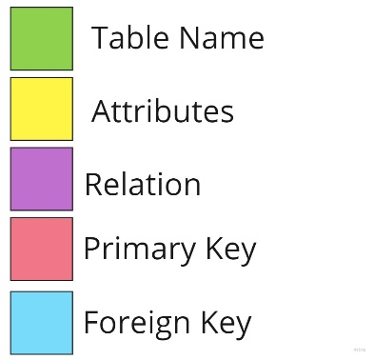

Follow this link to this Miro Board:

<https://miro.com/app/board/uXjVPrRpXnQ=/?share_link_id=19268088402>

**Group Members: -**

1. Abhijeet Anand – 2021509

2. Ashwani – 2021521